1.Check The List of All Daemons using command in below screent shot

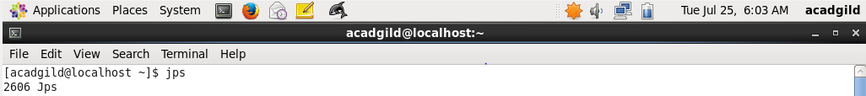

2. Start the ssh Server. On Providing command “ sudo service sshd start” system will prompt for root user password. Enter the password and click “ENTER”. SSh Server will start.



3. Start all the daemons using command “start-all.sh”, as shown in below screen shot.

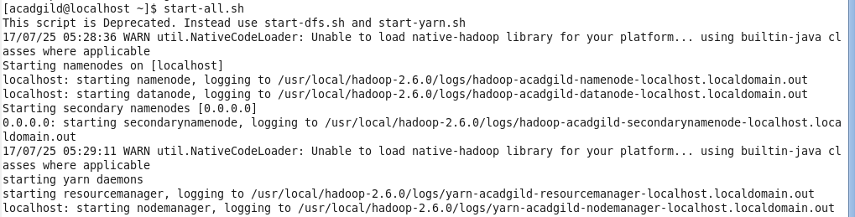

4. Now verify whether all the expected process are running using command ‘jps’.

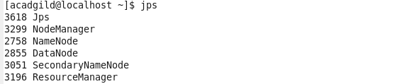

5. Now start history server and verify process is started or not using jps command

